

|  |
| --- |
| **ASSIGNMENT TOP SHEET**  **Faculty of Creative Arts, Technologies & Science**  **Department of Computer Science and Technology** |

|  |  |
| --- | --- |
| Student Ref. No: 1946040 | Unit Code  **CIS017-1** |

|  |  |  |
| --- | --- | --- |
| Unit Name  **Computer Systems Structure** |  | Deadline for Submission(s) |

|  |
| --- |
| Student Name: |

|  |
| --- |
| Unit Team |

|  |
| --- |
| **Assignment Details:**  **Assignment 1 – Design and Implement a Database** |

**Instructions to Students:**

**Please note**:

Work presented in an assessment must be your own. Plagiarism is where a student copies work from another source, published or unpublished (including the work of another student) and fails to acknowledge the influence of another’s work or to attribute quotes to the author. Plagiarism is an academic offence and the penalty can be serious. The University’s policies relating to Plagiarism can be found in the regulations at <http://www.luton.ac.uk/livingandstudying/qa/documents>. To detect possible plagiarism we may submit your work to the national plagiarism detection facility. This searches the Internet and an extensive database of reference material including other students’ work. Once your work has been submitted to the detection service it will be stored electronically in a database and compared against work submitted from this and other universities. It will therefore be necessary to take electronic copies of your materials for transmission, storage and comparison purposes and for the operational back-up process. This material will be stored in this manner indefinitely.

**I have read the above information and I confirm that this work is my own and that it may be processed and stored in the manner described.**

**Signature (Print Name): SHARMILA SHIVANA MOHAMMED Date: November 27, 2020**

Extension deadline

Mitigation Team agrees that the assignment may be submitted ____ days after the deadline and should be marked without penalty.

Mitigation Team confirmation.................................................................................................................

**All assignments must be electronically submitted using Turnitin (via BREO) by 10am on the due date**. Please leave sufficient time to meet this deadline and do not leave the handing-in of assignments to the last minute. You need to allow time for any system problems or other issues.

Contents

INTRODUCTION 2

ASSUMPTIONS 2

ENTIY RELATIONSHIP MODEL 3

NORMALIZATION 4

SKELETON TABLES 4

DATA DICTIONARY 5

QUERIES 6

IMPLEMENTATION OF THE DATABASE 7

DISCUSSION AND REFLECTION 13

APPENDIX 14

Create Database 14

Create Tables 14

Customer 14

HotelManager 14

Room 15

Booking 15

Insert Statements 15

Customer 15

HotelManager 16

Room 16

Booking 16

Queries 16

List of all Customer that has bookings in December 2020 16

List of Hotel Managers and Room assignments completed 16

List of Rooms utilized during December 2020 17

List of Bookings for Christmas Eve 2020 17

Pull a specific Customer details based on Customer Name 17

# INTRODUCTION

An analysis and investigative approach was taken to fully understand the processes involved within a Hotel. Based on the outcome from this, it was recommended for a creation of a Hotel Booking System. The following sections details the tasks required for the creation and implementation of a Database to fulfil this need, which includes Entity Relationship Modelling (ERM), Normalization, Physical Table Design, Query Design and Implementation of the Database.

# ASSUMPTIONS

Some assumptions about this database are as follows:

1. Within the Customer table, it is assumed that each customer has only one (1) credit card or one (1) form of payment.
2. Within the Room table, it is assumed that:

|  |  |  |
| --- | --- | --- |
| Room Type | Num of Beds | Num of Occupancies |
| Single | 1 Bed | 1-2 guest |
| Double | 2 Beds | 1-4 guest |

1. Within the Booking table, it is assumed that there are currently 4 types of booking status, which are, Pending, Assigned, Cancelled and Checked In.
2. Within the Queries table, it is assumed that the highest peeked period for the Hotel is the month of December, therefore statistics are being generated for upcoming expansions based on the December bookings.

# ENTIY RELATIONSHIP MODEL

This Entity Relationship Model (ERM) identifies the relationship between the entities and their attributes also defining the relationship between each entity.

The relationships seen are as follows:

There is one Customer to multiple Bookings, however, a customer makes a booking and a booking is made by a customer. One Staff to multiple Booking, as a staff assigns a room to the booking, but a booking maybe assigned by a staff member to a room. One Room to multiple Bookings, as a room may be matched to a booking, however, a booking must be assigned to a room.

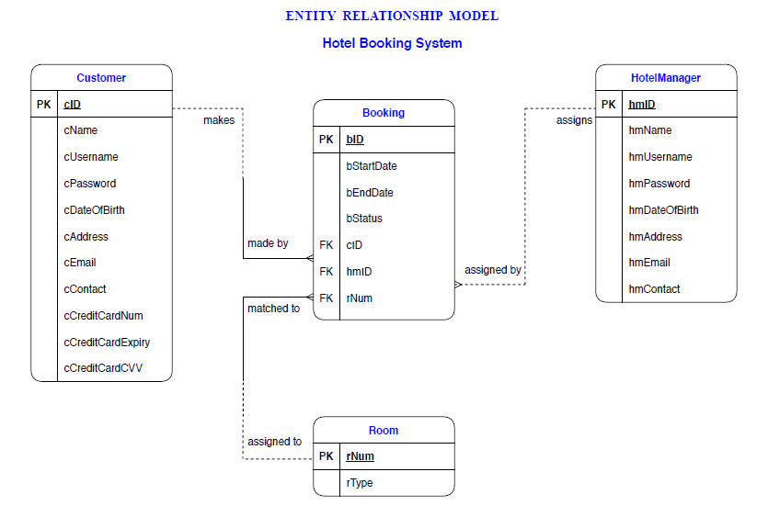Figure 1.1: Entity Relationship Model

# NORMALIZATION

During the analysis of the Normalization process, moving from Second Normalized Form (2NF) to Third Normalized Form (3NF), there were no non-key attributes partially dependant on another non-key attribute.

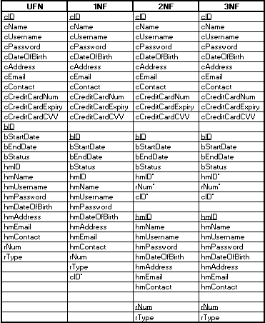

Figure 2.1: Normalization

# SKELETON TABLES

Within this diagram the Primary Keys (PK) are underlined and the Foreign Keys (FK) are marked with an *‘*‘*. The Primary Key (PK) for the Customer entity is customer ID (cID), for the Booking entity it is booking ID (bID), for the HotelManager entity it is Hotel Manager ID (hmID) and for the Room entity the Primary Key is room number (rNum). The Foreign Keys (FK) are only found within the Booking Table attributes which are customer ID (cID), HotelManager ID (hmID) and room number (rNum).



Figure 3.1: Skeleton Tables

# DATA DICTIONARY

Within the database all the Primary Key (PK) attributes are auto incremented and assumes the same attributes as the Skeleton Table seen above.

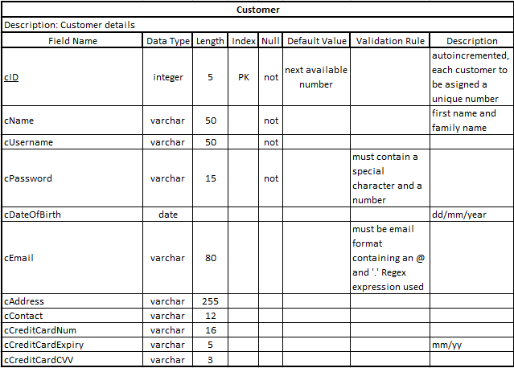

Figure 3.2: Data Dictionary – Customer Table

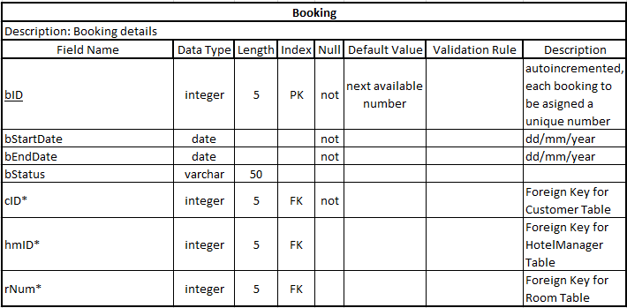

Figure 3.3: Data Dictionary – Booking Table

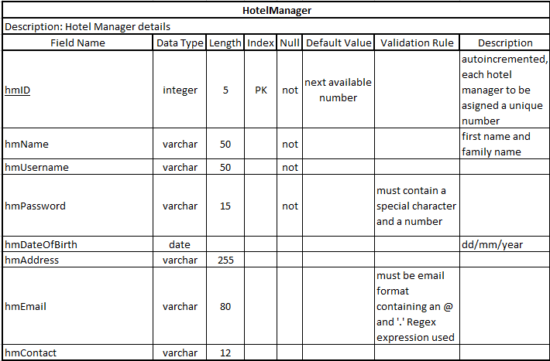

Figure 3.4: Data Dictionary – Hotel Manager Table

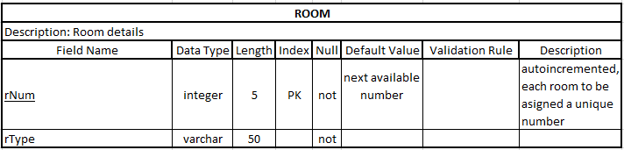

Figure 3.5: Data Dictionary – Room Table

# QUERIES

The following queries were developed to capture specific data, as seen justified below:

|  |  |  |
| --- | --- | --- |
| # | QUERY | JUSTIFICATION |
| 1 | List of all Customer that has bookings in December 2020. | To pull all of the bookings during the month of December 2020 to ensure they can be accommodated. |
| 2 | List of Hotel Managers and Room assignments completed | To pull list of hotel managers and their room assignments completed to be used for performance appraisals. |
| 3 | List of Rooms utilized during December 2020. | To pull list of Rooms utilized during December 2020, to gather statistics which will be used for upcoming expansions based on the December bookings. |
| 4 | List of Bookings for Christmas Eve 2020 | To extract list of Bookings for Christmas Eve 2020, to properly assign staff resources for this date, which will maximize optimal customer service. |
| 5 | Pull a specific Customer details based on Customer Name | This query can be used to obtain customer info in event of emergencies. |

# IMPLEMENTATION OF THE DATABASE

The following screenshots depicts the successful creation Database, Tables, Insert Data and Queries using SQL Syntax Commands:

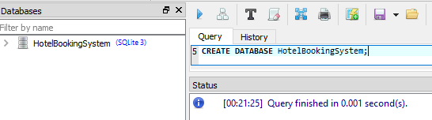

Figure 5.1 : Creation of Database

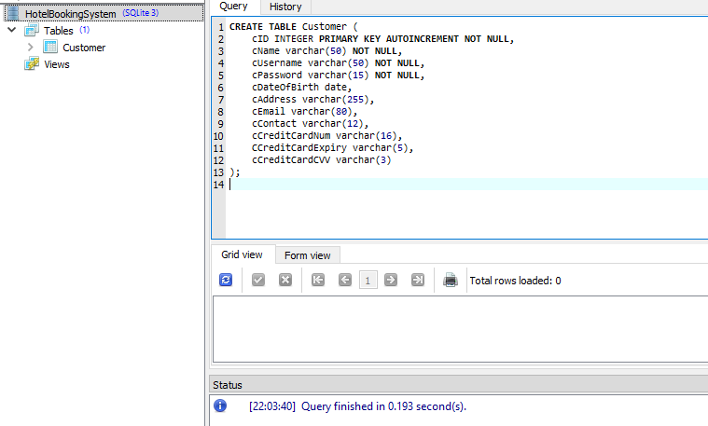

Figure 5.2: Creation of Customer Table

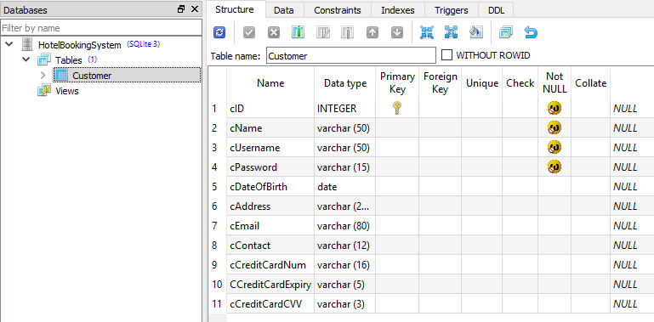

Figure 5.3: Structure of Customer Table

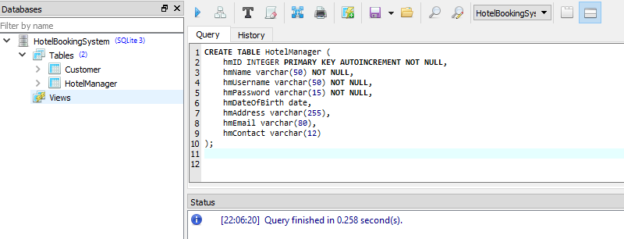

Figure 5.4: Creation of Hotel Manager Table

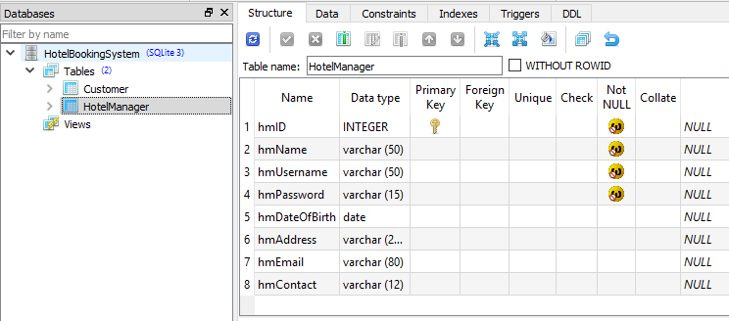

Figure 5.5: Structure of Hotel Manager Table

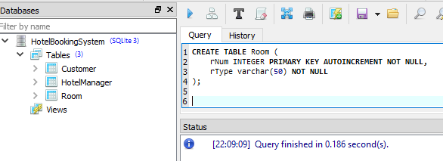

Figure 5.6: Creation of Room Table

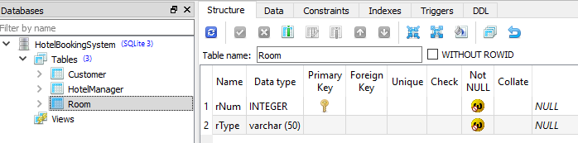

Figure 5.7: Structure of Room Table

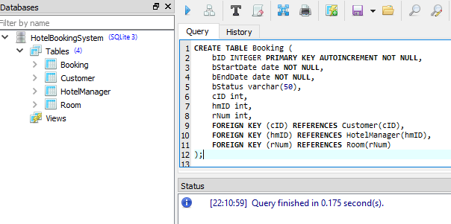

Figure 5.8: Creation of Booking Table

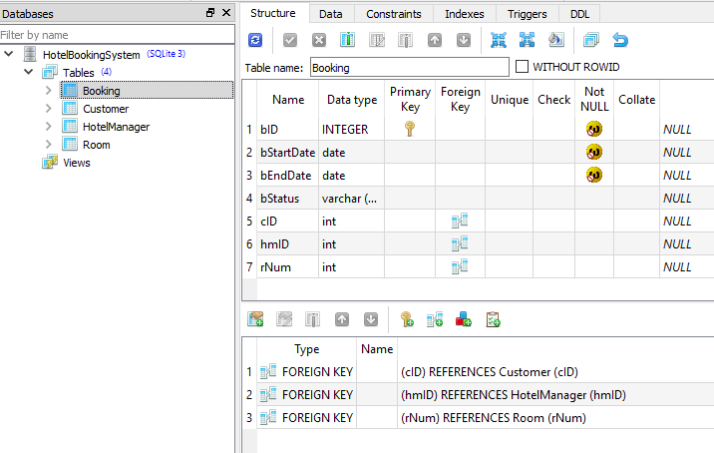

Figure 5.9: Structure of Booking Table

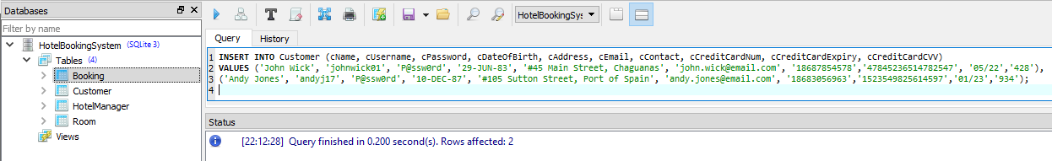

Figure 5.10: Populating Customer Table

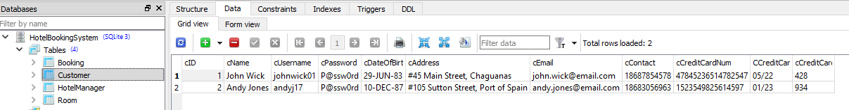

Figure 5.11: Data on Customer Table

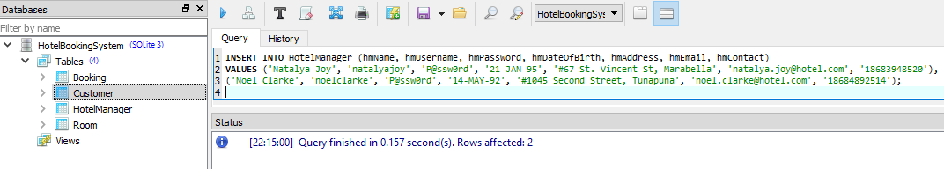

Figure 5.12: Populating Hotel Manager Table

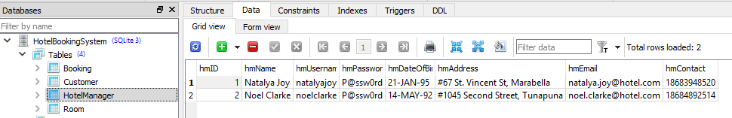

Figure 5.13: Data on Hotel Manager Table

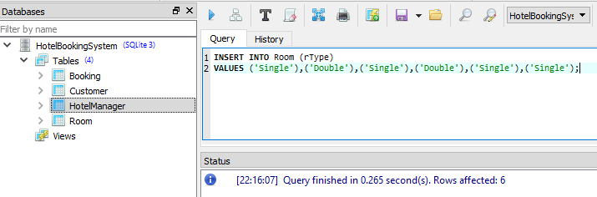

Figure 5.14: Populating Room Table

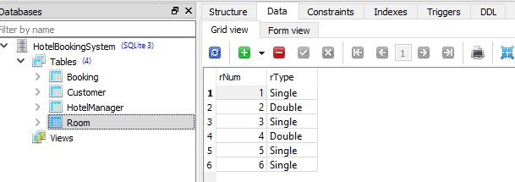

Figure 5.15: Data on Room Table

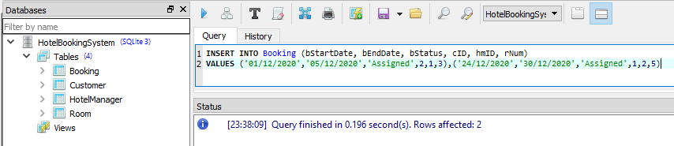

Figure 5.16: Populating Booking Table

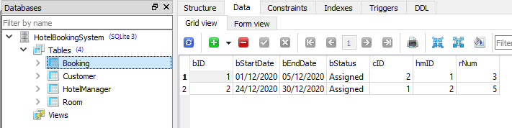

Figure 5.17: Data on Booking Table

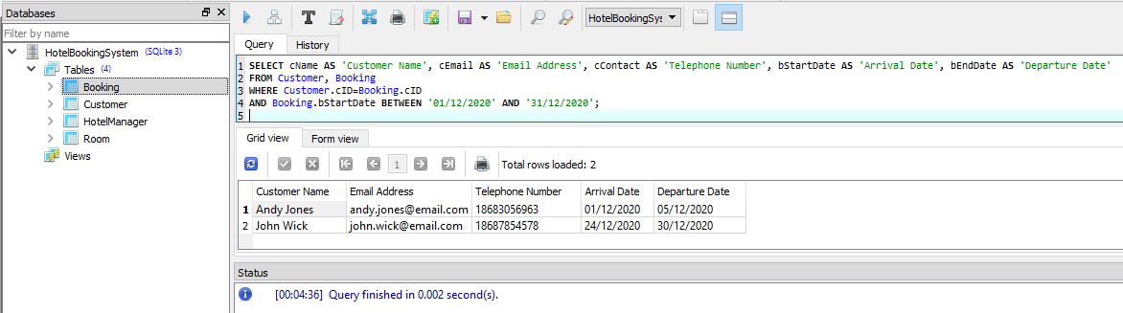

Figure 5.18: Query - List of all Customer that has bookings in December 2020

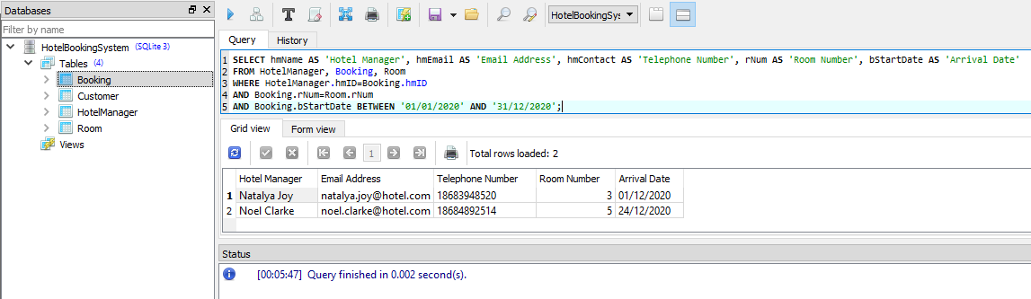

Figure 5.19: Query - List of Hotel Managers and Room assignments completed

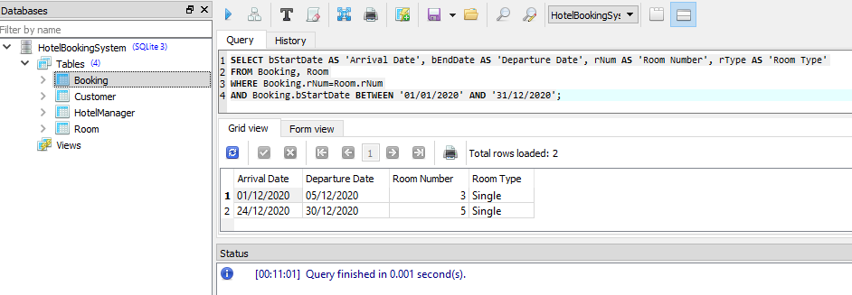

Figure 5.20: Query - List of Rooms utilized during December 2020

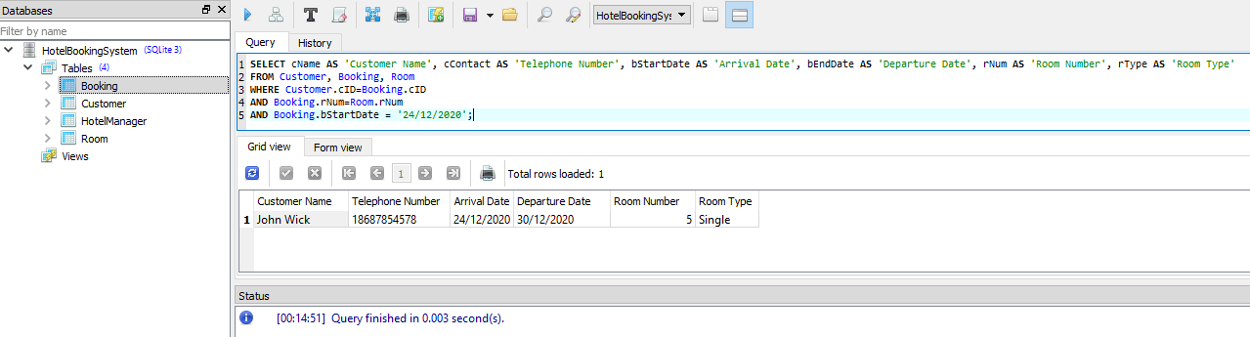

Figure 5.21: Query - List of Bookings for Christmas Eve 2020

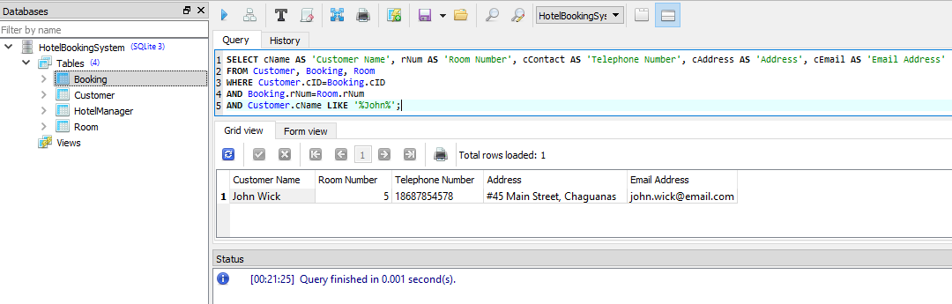

Figure 5.21: Query - Pull a specific Customer details based on Customer Name

# DISCUSSION AND REFLECTION

A very interesting assignment, which involved a lot of research apart from the course materials to gain a better understanding of SQLs Syntax and the commands required for Database creation and implementation.

With starting from the ERM and moving to the Implementation there were a lot of going back and adding and “*Ah Ha… moments*” with lots of constant changes to be made. Also with my personal setbacks and challenges, having to restart the assignment on multiple occasions, really made this an interesting experience. Really had a greater appreciation for the assignment as it was personal and not grouped, as this time, I had to create everything and understand how things fit in order to ensure a successful implementation.

# APPENDIX

The following outlines the SQL syntax used for creating Database, Tables, Data Entry and Queries.

## Create Database

CREATE DATABASE HotelBookingSystem;

## Create Tables

### Customer

CREATE TABLE Customer (

cID INTEGER PRIMARY KEY AUTOINCREMENT NOT NULL,

cName varchar(50) NOT NULL,

cUsername varchar(50) NOT NULL,

cPassword varchar(15) NOT NULL,

cDateOfBirth date,

cAddress varchar(255),

cEmail varchar(80),

cContact varchar(12),

cCreditCardNum varchar(16),

CCreditCardExpiry varchar(5),

cCreditCardCVV varchar(3)

);

### HotelManager

CREATE TABLE HotelManager (

hmID INTEGER PRIMARY KEY AUTOINCREMENT NOT NULL,

hmName varchar(50) NOT NULL,

hmUsername varchar(50) NOT NULL,

hmPassword varchar(15) NOT NULL,

hmDateOfBirth date,

hmAddress varchar(255),

hmEmail varchar(80),

hmContact varchar(12)

);

### Room

CREATE TABLE Room (

rNum INTEGER PRIMARY KEY AUTOINCREMENT NOT NULL,

rType varchar(50) NOT NULL

);

### Booking

CREATE TABLE Booking (

bID INTEGER PRIMARY KEY AUTOINCREMENT NOT NULL,

bStartDate date NOT NULL,

bEndDate date NOT NULL,

bStatus varchar(50),

cID int,

hmID int,

rNum int,

FOREIGN KEY (cID) REFERENCES Customer(cID),

FOREIGN KEY (hmID) REFERENCES HotelManager(hmID),

FOREIGN KEY (rNum) REFERENCES Room(rNum)

);

## Insert Statements

### Customer

INSERT INTO Customer (cName, cUsername, cPassword, cDateOfBirth, cAddress, cEmail, cContact, cCreditCardNum, cCreditCardExpiry, cCreditCardCVV)

VALUES ('John Wick', 'johnwick01', 'P@ssw0rd', '29-JUN-83', '#45 Main Street, Chaguanas', 'john.wick@email.com', '18687854578','47845236514782547', '05/22','428'),

('Andy Jones', 'andyj17', 'P@ssw0rd', '10-DEC-87', '#105 Sutton Street, Port of Spain', 'andy.jones@email.com', '18683056963','1523549825614597','01/23','934');

### HotelManager

INSERT INTO HotelManager (hmName, hmUsername, hmPassword, hmDateOfBirth, hmAddress, hmEmail, hmContact)

VALUES ('Natalya Joy', 'natalyajoy', 'P@ssw0rd', '21-JAN-95', '#67 St. Vincent St, Marabella', 'natalya.joy@hotel.com', '18683948520'),

('Noel Clarke', 'noelclarke', 'P@ssw0rd', '14-MAY-92', '#1045 Second Street, Tunapuna', 'noel.clarke@hotel.com', '18684892514');

### Room

INSERT INTO Room (rType)

VALUES ('Single'),('Double'),('Single'),('Double'),('Single'),('Single');

### Booking

INSERT INTO Booking (bStartDate, bEndDate, bStatus, cID, hmID, rNum)

VALUES ('01/12/2020','05/12/2020','Assigned',2,1,3),('24/12/2020','30/12/2020','Assigned',1,2,5)

## Queries

### List of all Customer that has bookings in December 2020

SELECT cName AS 'Customer Name', cEmail AS 'Email Address', cContact AS 'Telephone Number', bStartDate AS 'Arrival Date', bEndDate AS 'Departure Date'

FROM Customer, Booking

WHERE Customer.cID=Booking.cID

AND Booking.bStartDate BETWEEN '01/12/2020' AND '31/12/2020';

### List of Hotel Managers and Room assignments completed

SELECT hmName AS 'Hotel Manager', hmEmail AS 'Email Address', hmContact AS 'Telephone Number', rNum AS 'Room Number', bStartDate AS 'Arrival Date'

FROM HotelManager, Booking, Room

WHERE HotelManager.hmID=Booking.hmID

AND Booking.rNum=Room.rNum

AND Booking.bStartDate BETWEEN '01/01/2020' AND '31/12/2020';

### List of Rooms utilized during December 2020

SELECT bStartDate AS 'Arrival Date', bEndDate AS 'Departure Date', rNum AS 'Room Number', rType AS 'Room Type'

FROM Booking, Room

WHERE Booking.rNum=Room.rNum

AND Booking.bStartDate BETWEEN '01/01/2020' AND '31/12/2020';

### List of Bookings for Christmas Eve 2020

SELECT cName AS 'Customer Name', cContact AS 'Telephone Number', bStartDate AS 'Arrival Date', bEndDate AS 'Departure Date', rNum AS 'Room Number', rType AS 'Room Type'

FROM Customer, Booking, Room

WHERE Customer.cID=Booking.cID

AND Booking.rNum=Room.rNum

AND Booking.bStartDate = '24/12/2020';

### Pull a specific Customer details based on Customer Name

SELECT cName AS 'Customer Name', rNum AS 'Room Number', cContact AS 'Telephone Number', cAddress AS 'Address', cEmail AS 'Email Address'

FROM Customer, Booking, Room

WHERE Customer.cID=Booking.cID

AND Booking.rNum=Room.rNum

AND Customer.cName LIKE '%John%';